Women Techstar Bootcamp 5.0

Capstone Group 24 Project

Group Name: InsighthHER Africa

Project Title: AI-Driven Skills Gap Analysis: Understanding Unemployment Across Africa

Executive Summary
This project presents a data-driven analysis of unemployment patterns across Africa, using 2024 country-level data to identify key drivers, demographic disparities, and structural labour market challenges.
The analysis shows that Africa’s average unemployment rate is 10.75%, with significant regional variation. Southern Africa records the highest rates (~17.9%), while West Africa has the lowest (~5.2%), reflecting differences in economic structure and labour market dynamics. Youth aged 15–24 are the most affected group (~20%), while tertiary-educated individuals also face high unemployment (~15.3%), revealing a mismatch between education and job market demand.
Using data analytics, Power BI visualization, and AI-assisted insight generation, the project identifies three core challenges: a youth employment crisis, a structural skills mismatch, and a digital access gap. These insights are translated into actionable recommendations, including expanding vocational training, aligning education with industry needs, and improving digital inclusion.
The project delivers an interactive dashboard and evidence-based policy insights to support governments, educators, and labour market stakeholders in making informed, data-driven decisions to reduce unemployment across Africa.

1. Project Overview
Unemployment remains a critical challenge across Africa, particularly among young people, despite the continent’s growing and dynamic population. Structural issues such as skills mismatch, limited industrial growth, and unequal access to opportunities continue to hinder labour market participation across many African countries.
This project analyzes unemployment patterns across Africa using 2024 country-level data to uncover key drivers and structural labour market gaps. Rather than focusing on a single country, the study adopts a continental perspective to identify common trends, regional disparities, and shared challenges.
The project integrates data analysis, Power BI visualization, and AI-assisted insights to move beyond descriptive statistics toward actionable intelligence. By combining these approaches, the study provides a clearer understanding of how factors such as age, education, gender, and digital access influence unemployment outcomes across African countries.
The goal is not only to explain unemployment patterns but to generate practical, data-driven recommendations that can support policy design, workforce development, and economic planning across the continent.
2. Problem Statement
Youth unemployment remains a critical and persistent challenge across Africa, with millions of young people either unemployed or underemployed despite increasing levels of educational attainment. This disconnect highlights a deeper structural issue within labour markets — a mismatch between the skills possessed by job seekers and those demanded by employers.
While this challenge exists across the continent, it is particularly severe in South Africa, where unemployment rates remain among the highest globally. Factors such as limited job creation, inequality in access to quality education, and barriers to digital inclusion further exacerbate the issue.
Despite the availability of labour market data, there is a gap in integrated, data-driven analysis that connects unemployment trends with underlying structural drivers such as education, gender, and digital access. Additionally, limited use of advanced analytical tools reduces the ability to extract actionable insights from existing data.
This project addresses this gap by combining comparative data analysis with AI-assisted insights to better understand unemployment dynamics, with a focused case study on Africa, and to provide evidence-based recommendations for improving employment outcomes.

3. SDG Alignment
This project is aligned with the United Nations Sustainable Development Goals (SDGs), particularly SDG 8 (Decent Work and Economic Growth) and SDG 10 (Reduced Inequalities).
SDG 8 focuses on promoting sustained, inclusive economic growth, full and productive employment, and decent work for all. This study directly contributes to this goal by analyzing unemployment patterns across Africa and identifying structural barriers to employment, such as skills mismatch, limited job access, and inadequate alignment between education and labour market needs. The project’s recommendations — including vocational training expansion, youth employment programs, and improved education-industry alignment — support progress toward achieving productive employment outcomes.
In addition, the project aligns with SDG 10, which aims to reduce inequalities within and among countries. The findings reveal clear disparities in unemployment across regions, age groups, gender, and levels of digital access. For example, youth and women experience higher unemployment rates, while regions such as Southern Africa are disproportionately affected. By highlighting these inequalities and proposing targeted interventions, the project contributes to more inclusive economic participation.
Overall, this project supports SDG 8 and SDG 10 by providing data-driven insights that can inform policies aimed at improving employment opportunities, reducing inequality, and fostering inclusive growth across Africa.
4. Project Objectives
The objectives of this project are to:
- Analyse unemployment trends across Africa
- Identify regional and demographic patterns in unemployment
- Determine key drivers of unemployment
- Identify gaps between workforce skills and employer demands
- Use tools to extract patterns and generate insights
5. Target Users
The primary users of this project include:
- Policymakers and government agencies
- Educational institutions
- Job seekers, particularly youth
- Employers and labour market analysts
These stakeholders can use the insights to better understand unemployment trends and make informed decisions regarding skills development and employment strategies.
6. Data Sources
The dataset used in this analysis is based on 2024 country-level unemployment data sourced from The Global Economy, which provides country-level unemployment rates across African nations for the year 2024. To strengthen analytical interpretation, the data is contextualized using established global datasets such as World Bank indicators and International Labour Organization (ILO) labour statistics.
The dataset includes key variables such as:
- Country and region
- Age group
- Gender
- Education level
- Years of experience
- Internet access
- Area (urban/rural)
- Reasons for unemployment
Additional variables, particularly those related to skills gaps and unemployment drivers, were derived through analytical interpretation and AI-assisted categorization.
7. Data Cleaning and Preparation
The dataset underwent several preprocessing steps to ensure data quality and consistency:
- Standardization of variable names and formats
- Categorization of unemployment reasons
- Validation of data types for analysis
These steps ensured that the dataset was reliable and suitable for analysis.
8. Methodology
The analysis focuses on unemployment data for the year 2024, providing a snapshot of recent labour market conditions across Africa. The analysis was conducted using Excel Pivot Tables to examine unemployment trends across African countries. Country-level comparisons were used to identify regional disparities and patterns.
Power BI was used to visualize the data, while AI tools were applied to assist in identifying patterns, interpreting trends, and generating insights related to skills gaps and labour market dynamics.
9. Solution Explanation
The solution developed in this project is a data-driven analysis system that combines statistical analysis, visualization, and AI-assisted insights to better understand unemployment patterns in Africa.
The Power BI dashboard provides an interactive way to explore unemployment trends across countries and demographic groups, while the analytical component identifies key drivers such as age, education, and digital access. AI tools were used to enhance interpretation and highlight relationships within the data, particularly in identifying potential skills gaps.
This project goes beyond analysis by providing a decision-support system through an interactive dashboard and AI-assisted insights. Stakeholders can use the tool to identify high-risk groups, understand key unemployment drivers, and make data-informed policy and workforce development decisions.
10. Data Analysis and Key Findings
10.1 Regional Trends
The analysis reveals significant regional disparities in unemployment rates. Southern Africa has the highest average unemployment rate at 17.9%, while West Africa records the lowest at 5.2%. This suggests that structural economic differences and varying levels of industrial development influence employment opportunities across regions.
10.2 Age Group Analysis
Youth aged 15–24 experience the highest unemployment rate at 20%, making them the most vulnerable group. This indicates that first-time job seekers face structural barriers to entry into the labour market.
10.3 Education Level Analysis
An unexpected finding is that individuals with tertiary education have higher unemployment rates (15.3%) compared to those with lower education levels. This highlights a critical mismatch between academic training and industry requirements.
10.4 Gender Analysis
Women experience higher unemployment (11.5%) compared to men (9.9%). This gap reflects broader socio-economic challenges, including limited access to opportunities and structural barriers.
10.5 Digital Access
Individuals without internet access have higher unemployment rates compared to those with access. This demonstrates that digital connectivity plays a key role in improving employability.
10.6 Skills Gap Analysis
The analysis identifies a significant shortage of vocational and technical skills, with skills-related factors contributing heavily to unemployment. This suggests that many job seekers lack practical, job-ready skills required by employers, reinforcing the need for skills development programs. Skills gap insights were derived through a combination of data patterns and AI-assisted interpretation of labour market trends.
Summarily, the analysis reveals three core structural drivers of unemployment across Africa:
- Youth Employment Crisis: Young people aged 15–24 experience the highest unemployment rates (~20%), highlighting barriers to labour market entry.
- Education–Employment Mismatch: Individuals with tertiary education show higher unemployment rates than those with lower education levels, indicating a disconnect between academic training and labour market demand.
- Information and Access Gap: Factors such as poor career awareness and limited internet access contribute significantly to unemployment, suggesting that access to information and opportunity plays a critical role.
These findings demonstrate that unemployment in Africa is not solely a job availability issue, but a combination of structural, informational, and skills-related challenges.
11 Dashboard Explanation
The Power BI dashboard provides a visual representation of unemployment patterns across Africa.
Key visuals include:
- Unemployment rate by country
- Regional comparisons
- Age group distribution
- Gender-based analysis
- Education level impact
- Experience vs unemployment trends
The dashboard highlights clear disparities across regions and demographics, enabling easier interpretation of complex data patterns. It also supports the identification of high-risk groups and key drivers of unemployment.
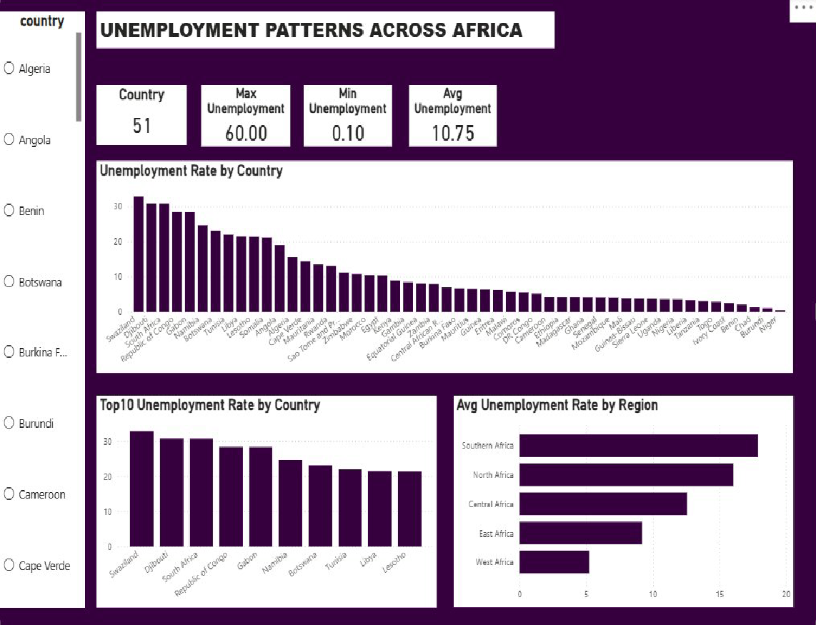
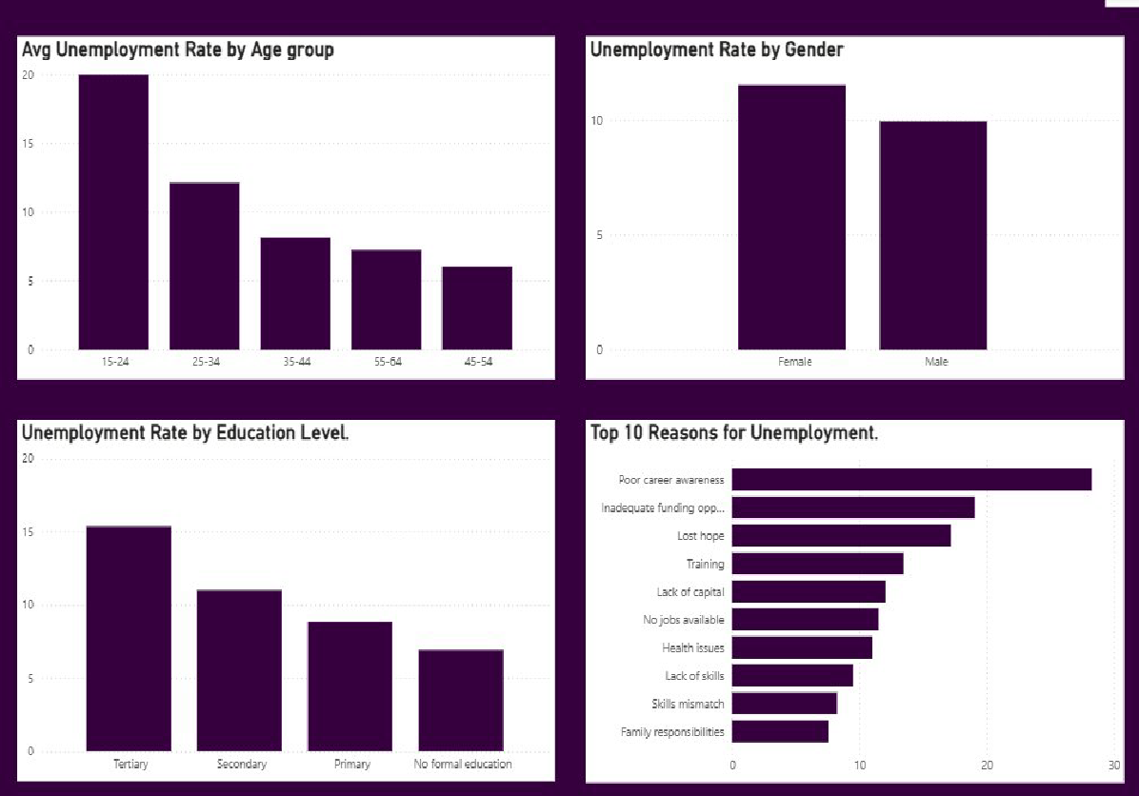
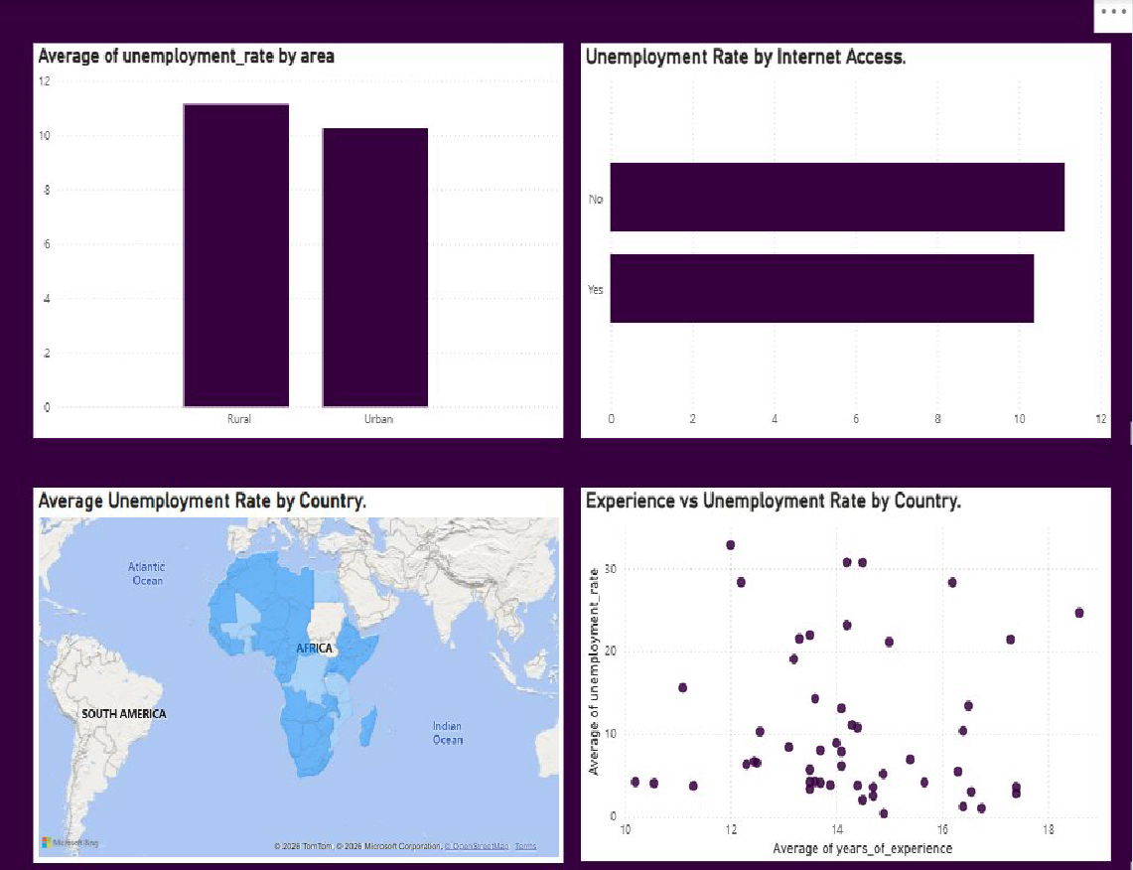
12. AI Component
AI was integrated as an analytical support tool to enhance insight generation and pattern interpretation within the dataset.
AI Tools Used:
- Claude AI
- ChatGPT (for structured insight refinement and explanation)
How AI Was Applied:
- Pattern detection across demographic and regional variables
- Identification of relationships between unemployment drivers (e.g., education, digital access, experience)
- Thematic grouping of unemployment reasons into structured categories (e.g., skills gap, funding constraints, career awareness)
- Refinement of analytical insights into clear, decision-ready findings
Value Added by AI:
- Accelerated identification of non-obvious patterns (e.g., education paradox)
- Improved clarity and depth of insight interpretation
- Supported the transformation of raw data into actionable recommendations
AI was used as a complementary analytical layer, with all outputs critically reviewed to ensure accuracy and contextual relevance.
13. Development Process & Lessons Learned
Development Process:
- Data sourcing and validation
- Data cleaning and preparation
- Exploratory data analysis
- Dashboard creation in Power BI
- AI-assisted insight generation
Lessons Learned:
- The importance of clean and reliable data
- The value of teamwork and task coordination
- AI tools are useful but require critical evaluation
- Effective data storytelling improves the communication of insights
14. Recommendations
Based on the findings, the following recommendations are proposed:
1. Implement Youth Employment Programs:
- Industries must be encouraged to implement apprenticeships and internships, and provide entry-level job opportunities
2. Expand vocational and digital skills training aligned with high-demand sectors identified in the analysis (e.g., technical and digital roles):
- Increase TVET institutions and encourage enrolment
- School syllabi should focus on practical, industry-relevant skills

3. Implement Education Reform
- Align academic curricula with labour market needs
- Introduce industry partnerships

4. Expand Digital Inclusion
- Governments need to expand internet access and promote digital literacy
5. Implement Gender-Inclusive Policies
- Laws must be created in support of women in the workforce
- Improve access to childcare and flexible work

6. Encourage Economic Diversification
- Reduce reliance on only some industries
- Promote entrepreneurship and innovation
15. Limitations
This study is subject to several limitations that should be considered when interpreting the findings:
- Use of Secondary Data: The analysis relies on country-level unemployment data sourced from The Global Economy. As a result, the study is limited by the accuracy, consistency, and update frequency of the original data source.
- Lack of Granular Data: The dataset primarily provides aggregated national unemployment rates and does not include detailed individual-level variables such as specific skills, job history, or employer requirements. This limits the ability to directly measure the skills gap and requires reliance on inferred insights.
- Limited Skills-Specific Data: Since the dataset does not explicitly contain information on skills demand or supply, conclusions regarding the skills gap are based on interpretation and AI-assisted insights rather than direct measurement.
- Regional Generalization: While the analysis highlights regional patterns, differences within countries (e.g., urban vs rural disparities) are not fully captured, which may mask localized unemployment challenges.
- AI Interpretation Bias: The AI component was used to support insight generation and pattern recognition. However, AI-generated insights may introduce bias or oversimplify complex socio-economic factors if not critically evaluated.
- Dynamic Nature of Labour Markets: Unemployment trends are influenced by rapidly changing economic, political, and social factors. Therefore, the findings represent a snapshot in time and may not fully reflect future labour market conditions.
- Time-Specific Data: The analysis is based on 2024 data and represents a snapshot of unemployment conditions during that period. Trends may change over time due to economic, political, or global factors.

16. Conclusion
This project set out to analyse unemployment trends across Africa to better understand the structural drivers of unemployment and identify actionable solutions. Through a combination of data analysis and AI-assisted insights, the study uncovered key challenges, including the youth unemployment crisis, the education-employment mismatch, gender disparities, and the impact of limited digital access on job opportunities.
By integrating multiple data sources and leveraging AI to enhance pattern recognition and insight generation, the project moved beyond descriptive analysis to provide a more nuanced understanding of labour market dynamics. The findings highlight the urgent need for targeted interventions that align education with market demands, expand access to digital skills, and address systemic inequalities.
The interactive dashboard and analytical outputs developed in this project serve as practical tools for policymakers, development organizations, and other stakeholders to make informed, data-driven decisions. While the study is limited by data availability and scope, particularly across diverse African contexts, it provides a strong foundation for further research and more localized interventions.
Ultimately, addressing unemployment in South Africa and across Africa requires a combination of data-driven policy, strategic investment in human capital, and the effective use of technology, including AI, to drive inclusive and sustainable economic growth.
17. Team Contributions
- Proposal writing and Group Representative
- Mpho Ngwigwa - WTB/2026/5.0/2463

- Data Collection and Cleaning Team – gathered datasets and prepared the data:
- Roua Ouerfelli - WTB/2026/5.0/2857
- Adeyemi Cynthia - WTB/2026/5.0/0676
- Mwiza Gondwe - WTB/2026/5.0/2794
- Butake Violet Mbun - WTB/2026/5.0/1722
- Analysis Team – conducted analysis
- Adebiyi Raheemah Bukola - WTB/2026/5.0/1410
- AI Team – generated insights
- Anwuli Ogu - WTB/2026/5.0/1114
- Opara Chinenye Anastasia - WTB/2026/5.0/0285
- Loveth Alphonsus

- Visualization Team – built the project dashboard
  - Precious Ajisefini - WTB/2026/5.0/1166
  - Deborah Happiness Njenga - WTB/2026/5.0/1042

- GitHub Manager- Created and managed the GitHub repository
  - Philip Toluwalope Gloria - WTB/2026/5.0/2943

- Group Secretaries and Documentation Team – served as the project group’s secretaries and compiled all reports across teams into a single project document and slide deck for presentation.

- Sinegugu Mpungose – WTB/2026/5.0/2634
- Eunice Adepoju - WTB/2026/5.0/0663

